IDEATION PHASE – 1. BRAINSTORMING
Date | 8/10/2026
Team ID | 9100Orbit
Project Name | Implement Client Script & UI Policy (Incident)
Maximum Marks | 4 Marks

Brainstorm & Idea Prioritization Template
Brainstorming provides a free and open environment that encourages everyone within a team to participate in creative thinking and problem solving. For this project, the team focused on improving Incident data quality and enforcing business rules through ServiceNow UI-level controls.
Reference: Mural – Brainstorm and Idea Prioritization Template

Step-1: Team Gathering, Collaboration and Select the Problem Statement
The team reviewed the Incident-management workflow and identified that relying only on user awareness and manual checks can lead to incomplete, inconsistent, or incorrect Incident records. The selected problem is therefore to enforce conditional field behavior and validation directly at the user interface level.
Observation / Need | Possible Idea | Reason for Considering
Incomplete mandatory information | Conditionally make fields mandatory | Ensures required information is entered before submission.
High-impact Incident requires additional controls | Create a UI Policy based on Impact = 1 – High | Applies stricter controls only when the Incident is High Impact.
Urgency should be consistent for High Impact | Use an onChange Client Script | Automatically sets Urgency to High and reduces manual errors.
Incident should not save without Assigned To | Use an onSubmit Client Script | Prevents incomplete records from being submitted.
State should not be changed directly through list editing | Use an onCellEdit Client Script | Blocks direct list-view State changes.
Normal behavior should return when condition is false | Use Reverse if false | Reverts UI Policy changes when Impact is no longer High.
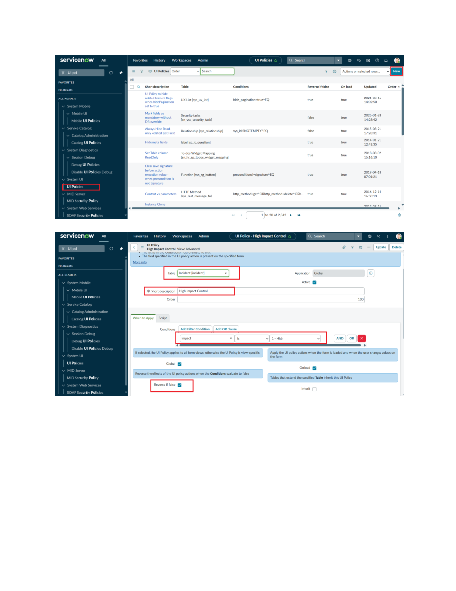
Figure 1. High Impact Control UI Policy configuration from the uploaded project PDF.

Step-2: Brainstorm, Idea Listing and Grouping
Idea Group | Brainstormed Ideas | Project Relevance
Data validation | Mandatory fields; save-time validation; error messages | Improves Incident data integrity.
Dynamic form behavior | Mandatory status; read-only controls; conditional behavior | Implemented through UI Policy Actions.
Automation | Auto-set Urgency for High Impact | Implemented through onChange Client Script.
Interaction control | Block State changes through list editing | Implemented through onCellEdit Client Script.
Testing and verification | Mandatory test; successful save; reverse condition; list edit; form update | Confirms all configured controls work correctly.
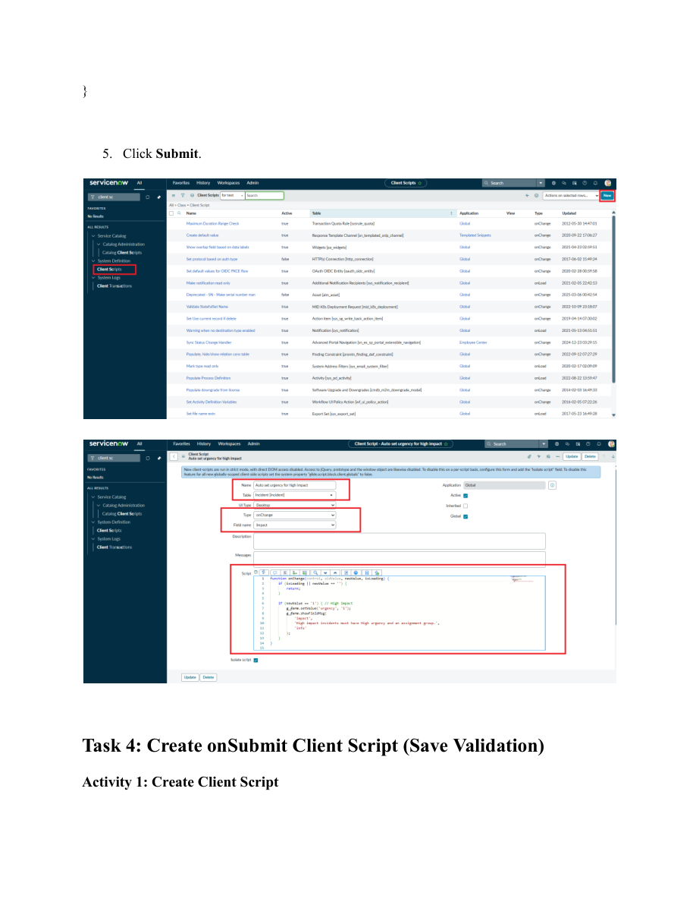
Figure 2. onChange Client Script configuration from the uploaded project PDF.

Step-3: Idea Prioritization
Priority | Idea | Impact | Feasibility | Decision
1 | UI Policy for High Impact and mandatory Assignment Group | High | High | Selected
2 | onSubmit validation for Assigned To | High | High | Selected
3 | onChange auto-set Urgency | High | High | Selected
4 | onCellEdit blocking State list edits | Medium–High | High | Selected
5 | Additional conditional field visibility | Medium | Medium | Future Enhancement
Final prioritized concept: combine UI Policies and Client Scripts to enforce Incident business rules, automate appropriate field behavior, and prevent invalid or unauthorized changes.
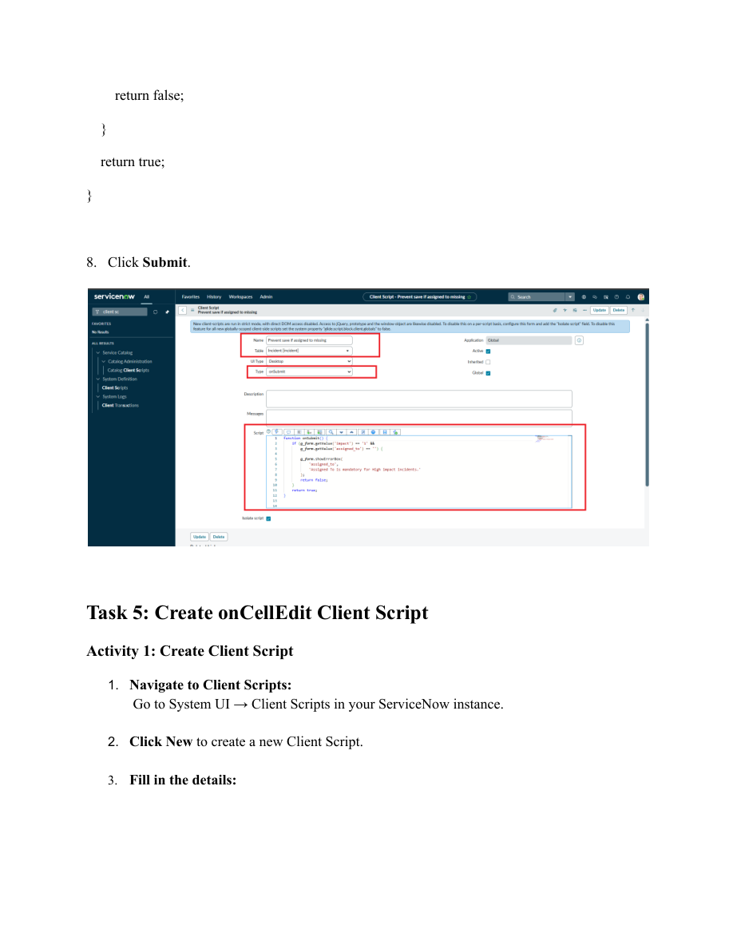
Figure 3. Save-validation Client Script shown in the uploaded project PDF.

